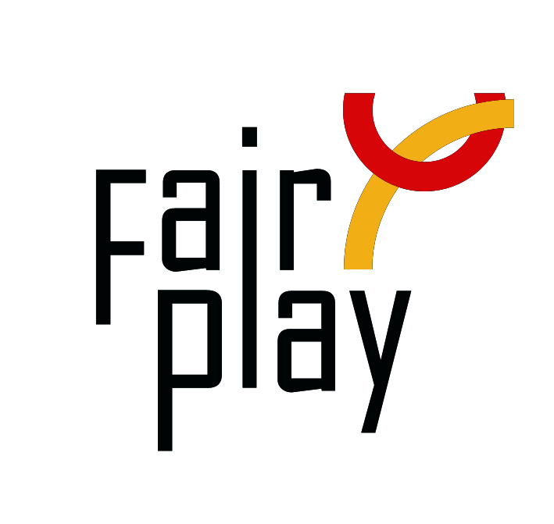
SUBMISSION OF CANDIDACY
QUESTIONNAIRE FOR C.I.F.P. AWARDS NOMINATIONS 2022

The C.I.F.P. awards distinctions for fair play under the following category each year:
Jacques Rogge World Fair Play Trophy for the Youth
To an athlete, or a team UNDER 20, for a gesture of fair play

- Details of the Youngster(s) proposed for the nomination:

Name, country:
E-mail:
Profession or current occupation / school:
Organization connected:

- Her/ his act of fair play:
Date of the act:
Place of the act (city, country):
Name of the competition:

- Description of the act or gesture: (max. 50 words):

- Initiative - Emphasize the initiative of the girl(s) or boy(s):

- Source (preferably in English):

----------------------------------------------------------------------------------------------------

Details of the person or organization submitting this nomination:

Name:
E-mail:

Date:

Please attach all available supporting evidence (photos, press clippings, reports etc.) justifying this nomination as well as a PHOTO
_________________________________________________________________________________

The CIFP awards are the following in the ascending order of merit:

I. Letter of Congratulations,
II. Diploma of Honor,

III. World Fair Play Trophies

Fully substantiated candidacies for 2022 World Fair Play Awards can be submitted by 15 February 2023 to the below address:

E-mail: nominations@fairplayinternational.org

International Fair Play Committee
Attn. Dr Jenő KAMUTI – President

H-1124 Budapest, Csörsz u. 49-51. Hungary

